Character Variables

Spriter is not just for making the animations for a game. It also allows for you to edit some of the “invisible” things associated with animations that effect aspects of game play.

One of the most powerful and flexible of these features is Character Variables. For each character you create you can also create an unlimited number of alterable variables associated with it, along with their default values. This on its own wouldn't be an especially useful feature except for the fact that you can trigger a change to any of these character Variables at any frame during any of the animations for that character!

Here are some of the possible uses for this feature:

- Imagine you are creating a complex fighting game in which every attack by the player can either be countered or not. You could create a variable for the character called “counterable” and by changing its value to either “YES” or “NO” for any given animation you have a very easy and visual way of controlling and tweaking not only what attack animations can be counter-attacked, but even during which frames of those animations.
- Many actions that a character in a game might make are the sort that leaves the character completely unresponsive to player input until the move is finished. Others, like walking, jumping etc are different because the player can interrupt this animation at any time by triggering a new action for the character to take, like an attack, etc. Creating a variable for the character, perhaps called “STUCK” and setting its value to either “YES” or “NO” for any given animation is a great way to control that within Spriter.
- The first two examples handle binary type decisions, either “yes or no”, “on or off” and use a text value for the sake of easy reading, however sometimes you need to use numerical values for greater control. You could use a Character Variable to keep track of the attack strength of a characters attack on a per frame basis! Or even trickier, lets say that if blocked, the characters attacks push the opponent backward a bit. You could use a variable called perhaps “BLOCK PUSH” and set the extent to which the opponent will get pushed back on a per animation and per frame basis.

These are just a few of the possibilities to get your imagination going. I'm sure you'll find lots of great uses for this feature that we haven't even thought of.

To create a Character Value you:
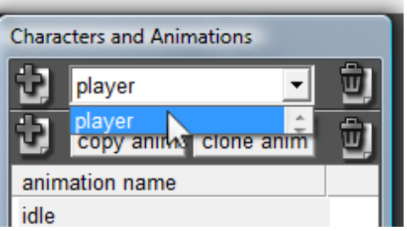
- Make sure the Character that you want to create a variable for is selected in the pull down “Character List” at the top of the “Characters and Animations ” window.

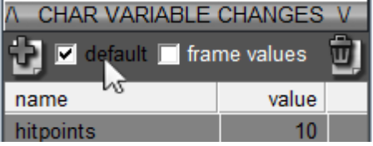
- Make sure the check box labeled “default” just above the “CHAR VARIABLE CHANGES” list is checked!

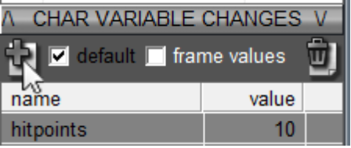
- Click on the “Create Character Variable “ button just to the left of the “default” check box mentioned in step 2 and use the dialogue that appears to give your new variable its desired name and its default value.

To set a new value for a Character Variable within one of its animations you:
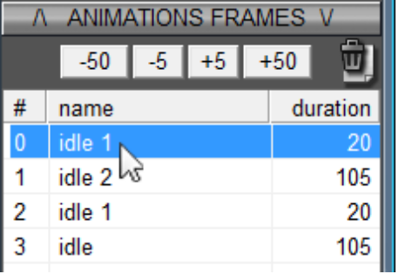
- Select the frame that you want to trigger a value change in from the “ANIMATIONS FRAMES ” list in the “Characters and Animations” window.

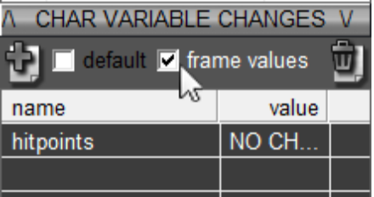
- Make sure the check box labeled “frame values” just above the “CHAR VARIABLES” list is checked!

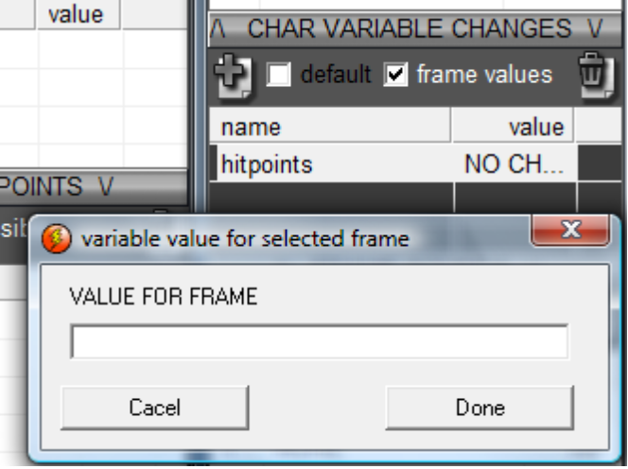
- Double click on the variable you want to set to a new value for THIS FRAME. Use the dialogue that will appear to set the new value. Keep in mind this does NOT change its default value! To edit the default value you must check the “default” check box first!

One last thing to note is that when you create a new Spriter file from scratch it automatically generates a black Character, Animation, Frame AND a Character Variable. You'll probable want to rename this initial Character Value and use it for whatever you want instead of leaving it there unused.

